DelCAM USA
FeatureCAM
2008
FeatureMILL 5-axis simultaneous Fundamentals
Student
Training Guide
FeatureCAm – featuremill 3D Fundamentals
Student Training Guide
© 2007
275 East South Temple • Suite 305
Phone 888.393.6455 • Fax 801.575.5017

Chapter 1 – Getting Started
Chapter
1
This course is designed to teach you the fundamentals of using 5-axis simultaneous with FeatureCAM to model and simulate the machining of three dimensional parts.

Before You Start
Before you begin this course, it is recommended that you are familiar with the FeatureCAM interface and have gone through the tutorials in the FeatureCAM Getting Started Guide and have taken the FeatureCAM 3D Fundamentals Course.

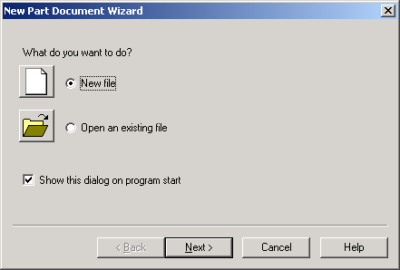
New Part Document Wizard
When you Start FeatureCAM the New Part Document Wizard is the first thing you see. Click Open an existing file to work on an old FeatureCAM file. Click on New File to begin a new part. Click Next and follow the instructions in the next two sections.

New File
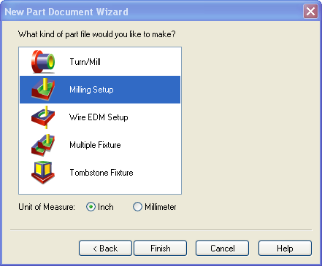
When you click New file in the New Part Document Wizard, the choices that you are offered will be limited by the FeatureCAM modules you have purchased. Initially you are offered the choices of a Turning or Milling or Turn/Mill Setup, Wire EDM Setup, Multiple or Tombstone Fixture, and a Unit of Measurement choice.

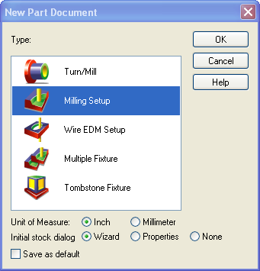
You can also click the New  button start a New Part after pressing Cancel in the New Part Document Wizard. You will also find this button on the Standard Toolbar once you are in the main FeatureCAM interface. This button can start a new part at any time without the need to close the current part.
The New Part Document dialog box has the same selections as the New Part Document Wizard with the addition of being able to select your Initial stock dialog options.

Once you have selected the type of part document you are going to create and the unit of measure, click the Finish button to proceed with defining your stock.

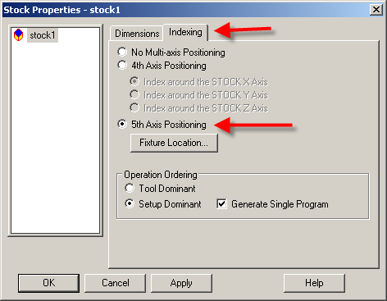
A 5-axis simultaneous surface milling feature requires your machine to have 5 degrees of freedom. For FeatureCAM, the 5 degrees of freedom are restricted to moving in X, Y and Z, and rotating in 2 single revolute rotational joints. (A single part of your machine can only rotate about one axis. Unlike the human wrist, for example, machine joints can only rotate about one mechanical axis).
That is, you may define 5-axis features in a Turn/mill document with a B-axis enabled post (.cnc file) so that your 5-degrees of freedom are X,Y,Z,B and C. For instance, a Mazak Integrex lathe that has a B-axis swiveling head. You may also use 5-axis features in a 5-axis indexed milling environment in a Milling document. (See the indexing tab of the stock properties).
Chapter
1

Chapter 1 5-Axis Terms
You should be familiar with Featurecam’s 3-d surface milling feature. This is the underlying technology for 5-axis simultaneous tool motions.

Some useful definitions:
- Tool axis: the orientation of the tool. For “normal” 3-axis milling, the tool axis is considered as (0,0,1) or the Z direction relative to the setup.
- Surface Normals: All surfaces and faces in solids have normals. These are vectors which are perpendicular to the surface they lie on. Solids generally have surface normals that point “outward”, whereas a random group of surfaces, such as an imported IGES file, may have randomly pointing normals.
- Lead: A toolpath has a cutting direction, for instance, an X-parallel’s cutting direction is roughly +x or –x while it is in contact with the surfaces (i.e., ignoring stepover moves). A lead angle is an angle between the tool axis and the cutting direction, for example, the lead angle is measured in the XZ plane for an X parallel. 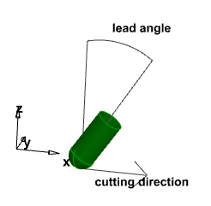

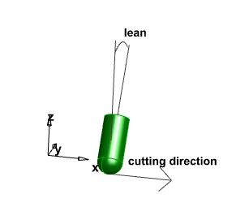
- Lean: In contrast, the lean angle is measured in a plane perpendicular to the lead angle’s (also perpendicular to the cutting direction) and is the angle through which the tool axis is rotated about the cutting direction. For example, an X-parallel’s lean angle is measured in the YZ plane. Picture yourself walking in the X direction. You can lead forward or backward (sometimes called lag), tilting yourself in the plus or minus X direction, or can lean to the left (+Y) or right (-Y).
- Swarf: The cutting is carried out with the side of the tool rather than the tip. This is used mainly to machine the sides of pockets in aerostructures and also for trimming composite components.
- Linearization: FeatureCAM will compute a 5-axis toolpath as a collection of points and tool axis direction vectors with the intent that the tooltip travels in a straight line between the points. What actually happens on the machine when two consecutive tool axis directions are not the same, is that the machine will rotate one or both indices. This rotational movement causes the tooltip to move in a non-linear fashion, i.e., not in a line. The term Linearization refers to generating intermediate tool motions to keep the tool tip moving along a straight path between tool positions calculated by FeatureCAM. That is, FeatureCAM toolpath computations tolerance the surface being machined, whereas the post (and simulation) must tolerance the machine's NC control point movement. In practice, you do not need to be concerned with Linearization, as FeatureCAM does linearization for you in both the posting process and the 3d- and machine- simulation based upon the “wrapping tolerance”.

Chapter 2
Chapter
2

Tool Axis
In an appropriate document type, with an appropriate post (.cnc file), some surface milling operations will have a Tool axis tab. The Tool Axis tab will let you control or define the tool orientation. The default value is Vertical which is used for standard 3-Axis machining. However, it can also be a continuously changing orientation for so-called 5-axis simultaneous machining.
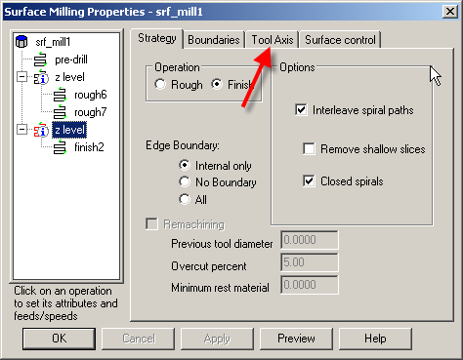

When showing the tool axis tab, the upper half of the dialog is concerned with how to position the tool axis during “normal” cutting.
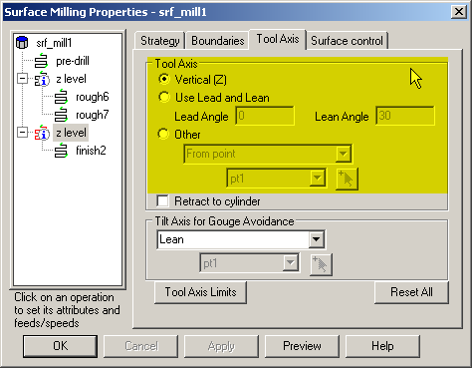
- Vertical - The tool remains aligned with the Z axis of the active setup. This is the default value and is the value used for standard 3 Axis machining.
- Lead/Lean - The tool is at a fixed angle relative to the direction of the toolpath.
  - Lead - the tool angle in the feed rate direction.
  - Lean - the tool angle perpendicular to the feed rate direction.
Lead/Lean can be used with isoline and flowline techniques to keep the tool normal to the surface being cut. These techniques can be used to cut “wrapped 3d grooves and pockets” without the need for extracting edge curves and unwrapping them. Lead/Lean is also useful to avoid cutting with the center of a ball-end tool, since the center has zero velocity in terms of RPM.
- Other, which has other choices from the drop-down list.
  - Toward Point - The tool tip always tries to point towards the fixed point. The head of the machine tool will move significantly whilst the tip of the tool remains relatively still. This option orientates the tip of the tool towards a point.
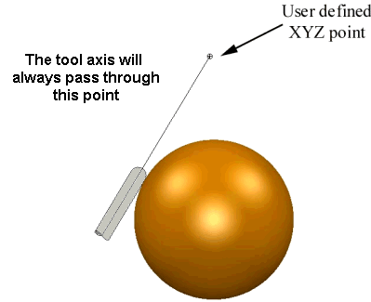
  - From Point - The tool tip always tries to point away from the fixed point. The tip of the tool will move significantly whilst the head of the machine tool remains relatively still. This option orientates the tip of the tool away from a point.
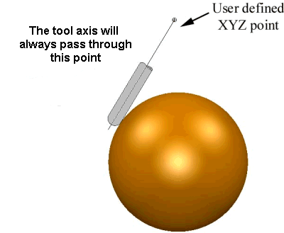
  - Towards Line - The tool tip always tries to point towards the fixed line. This is quite useful for cam-shafts. The head of the machine tool will move significantly whilst the tip of the tool remains relatively still. This option orientates the tip of the tool towards a line
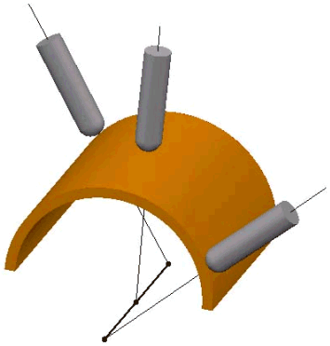

- From Line - The tool tip always tries to point away from the fixed line. The tip of the tool will move significantly whilst the head of the machine tool remains relatively still. This option orientates the tip of the tool away from a line.
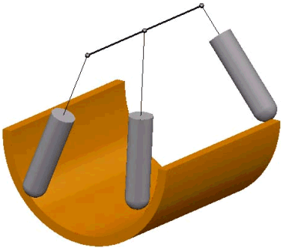
By way of an example, import blah.x_t into a TurnMill document. Align the Z-axis with the center hole as depicted below.
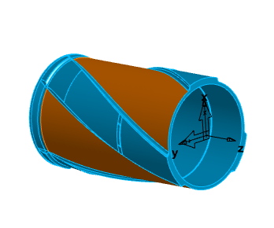
Assume you wish to turn the bulk of the outside, but now must do a little milling on the orange surfaces. As of FeatureCAM version 2007, you would be restricted to choosing either a 4-axis rotary finish (which would finish the whole part including the blue surfaces that don’t need to be machined as they were turned), or laboriously extracting edge curves, unwrapping and setting up a wrapped pocket or side. With FeatureCAM v2008, select one of the orange surfaces and create an isoline finish. Instead of keeping the tool axis aligned with Z, we will set the tool axis such that the axis will be normal to the surface at all points along the toolpath by using a Lead/Lean strategy with Lead angle of 0 and Lean angle of 0. Choose a large bullnose tool with tip radius <= .2362 (the radius of the fillets “along side” the orange surface) and an isoline direction of first column, decreasing, to get the toolpaths to run from front to back (Z). Since 5-axis toolpaths typically take a bit of tweaking to get them right, we recommend setting an initial tolerance bigger than desired, and a large stepover. To speed 3d-simulation use a large wrapping tolerance (Manufacturing -> Machining Attributes -> Milling Misc. tab), and a large Tool cutting tolerance (Options->Simulation->2d/3d Shaded tab). (Turn/mill angular interpolation and Tool visual tolerance in the same dialog also effect simulation speed to some extent). You should remember to reset the wrapping tolerance, stepovers, and surface milling tolerances smaller before you post NC code!
With an orange surface as a part surface, and a toolaxis lead/lean strategy, the toolpath will cut along the edge of the orange surface somewhat like:
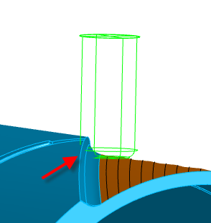
Notice the tool at the tip of the red arrow is gouging the blue face(s). In 3-axis surface milling, one might use “Edge boundary of Internal only” to control this behavior, but in 5-axis milling most, if not all, boundary control strategies “will not work” as you might expect. This is because the boundary or stock curve has to be in “tool space” and with a constantly changing tool axis, the boundary has to be redefined at each point of the toolpath. Fortunately, the work-around is to set all the blue faces as check surfaces. This will limit the toolpath as desired.
Chapter 3 Swarf
Chapter
3
With an isoline lead/lean setup as in Chapter 2, we now have to cut the fillet and ‘flat’ surface at the side(s) of the orange face. I.e., the red surfaces below:
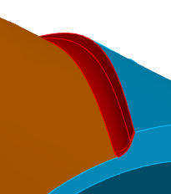
As a way of introduction to swarf cutting we will attempt to cut the fillet and the ‘flat’ surface in one operation. Note that this may not be theoretically correct (even for this case) or the most ideal way to approach this cut.
Swarf Cutting calculates toolpaths which will cut with the side of the tool and only works on developable surfaces as the tool needs to be in contact with the surface for the whole cutting depth. For a tool to swarf cut, it has to be able to have contact with the surface at all points along the cutting edge of the tool. For non-developable surface, FeatureCAM will always leave material on or produce fragmented toolpaths (rather than gouge). This means that you need to look at parts carefully before trying to swarf cut them. It may be that rotating the part (cutting from the side rather than the top of an aerofoil blade) may produce the desired result.
Create a surface milling feature with the “top” flat surface as the part surface.
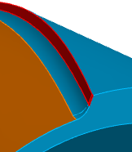
Create a swarf operation. Use a 12 mm ball-end tool such that it will “accidentally” cut the fillet at the bottom. Note that the desired toolpath may need to be “extended”. To accomplish this, visit the surface-from-surface menu and extend the “last row” of face_33 by 5 mm creating a new surface. Use this new surface as the part surface instead of face_33.
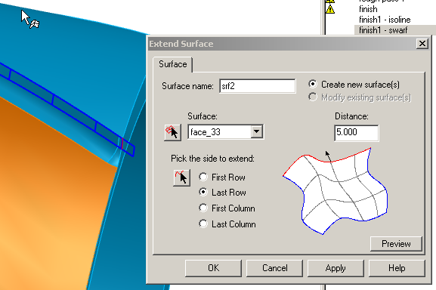

Preview the swarf toolpath carefully. Depending on the geometry selected there are 2 common problems:
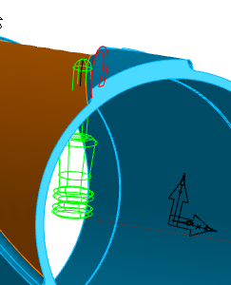
The tool is “upside-down” and gouges the part horribly. The solution to this problem is to visit the swarf “strategy” page, and check the Reverse tool axis checkbox. 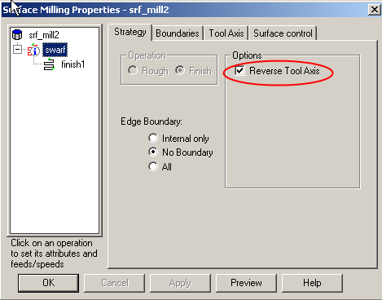
Unfortunately, there may be cases where the tool cuts one surface fine, but is upside-down for another surface of the feature. In this case, there is no recourse other than to create two surface milling features.

The other common mistake is that the toolpath is on the “wrong side” of the surface(s). Unless the feature has check surfaces, Featurecam will attempt to swarf cut the “outside” of the surface. For faces in a solid, the default of “outside” will usually be the correct side, however, if the part surfaces are just a random collection of surfaces (for example, imported surfaces from IGES), the outside versus inside may be totally random.
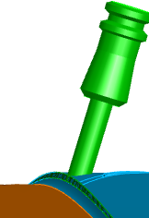 Cutting on the wrong side of the surface.

To correct this, the swarf operation has a surface control tab. Toggle the “surface side” (normal or reverse) ensuring that the arrow of the normal points outward (to the side you wish to cut).
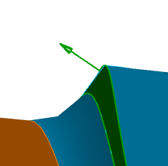

Chapter 4 Tilt for Gouge Avoidance
Chapter
4

The bottom-half of the tool axis dialog page is concerned with tilting the tool to avoid gouges with the holder or shank. By way of example, open the file
SW3dPS-Propeller tilt lean.fm
This is a simple example with a single surface isoline with a lead/lean angle(s) of 0 degrees to keep the tool normal to the surface (face_60). Run centerline or regular 3d simulation without showing the holder. The toolpaths look like they might work.
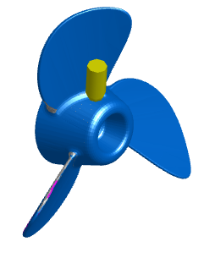
Now see what will really happen on the machine by running 3d sim with show holder, or run machine simulation. While the tool does avoid cutting the check surfaces, we see that the holder will collide with the part and/or check surfaces.
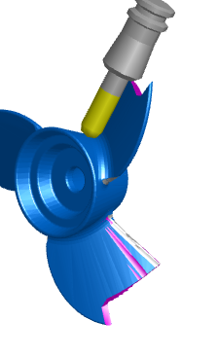
We can sometimes avoid these collisions by tilting the tool axis away from the check surfaces. In this case, use a lean strategy so that the tool will “lean away” from the check surfaces when necessary to avoid the check surface/holder clash. When it is not necessary to tilt the tool, the tool axis remains alignewith the surface normal, i.e., the tool axis strategy returns to “normal” whether it’s vertical, lead/lean, through point, etc. i.e., returns to the Tool Axis strategy in the top-half of the dialog box.
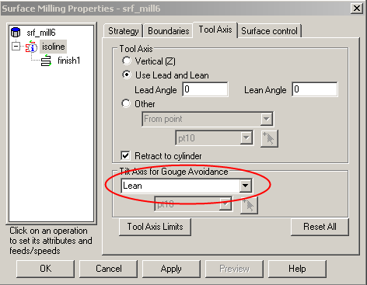
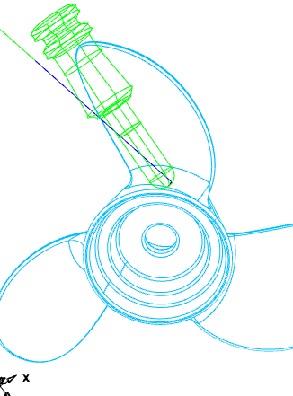
The resulting toolpath will tilt the tool perpendicular to the cutting direction when necessary to avoid hitting the propeller with the tool holder.
In this case, we need to run 3d simulation with fairly normal tolerances, i.e., you can and should ignore the advice to set wrapping tolerance, tool cutting tolerance, etc. to large values. To get a more accurate stock model in the simulation, start the simulation in a view which is more zoomed in. That is, the simulation is always dependent on the view scale. The more zoomed in you are, the more triangles you get in the stock tessellation. The more triangles you get, the more accurate the simulation. With large tolerances, the 3d simulation may show a false gouge.

With a tilting strategy of something other than “No tilting”, the holder and shank are gouge-checked. In addition, the “holder clearance” value is the minimum allowable distance between the part or check surfaces and the holder and/or shank (applies as an addition to the Check or Leave allowance).
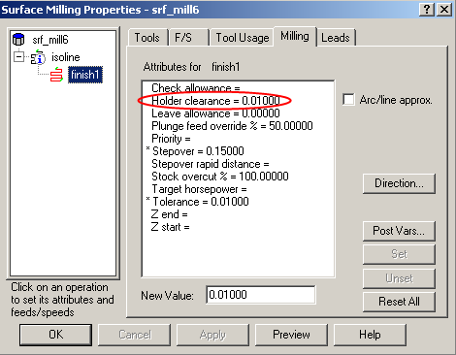
To use the B-axis (assuming a mill/turn Integrex-like machine) to avoid gouging the check surfaces, we would apply a Tilt axis for gouge avoidance strategy of Lead.

Chapter 5 Trim
Chapter
5
Another useful tool in 5-axis simultaneous is the 5-axis Trim operation. By way of example, import the file “syscam2.igs” into a Featurecam, turnmill metric document. 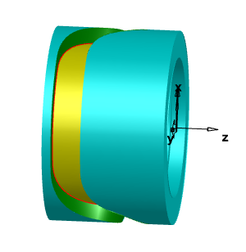
Assume that you wish to cut the yellow and green surfaces, that is, you want to mill the “groove” after you’ve turned the outer diameter. This is actually much harder than it looks. One way to cut it exactly would be to come up with the “groove curve” (in the middle of the groove), unwrap the curve, and take one pass at it with by using a tool that's the width of the groove with a “wrapped” groove feature. (Assuming the geometry is from a wrapped toolpath – there is no way in FeatureCAM to verify that the surfaces are indeed from a wrapped feature! I.e., it is usually just an educated guess if a wrapped feature will cut the surface geometry.) Coming up with a groove curve is actually quite difficult since you must get the exact “circular” curve in the exact middle of the groove. Since that curve was not supplied in the IGES data, reconstructing it from the surface data is difficult. Another approach to cut the “groove” would be to swarf the green surfaces, but that may not cut the bottom floor exactly/cleanly. An Isoline with lead/lean =0 doesn’t really work so well since the yellow surfaces are just trimmed cylinders, i.e., the isolines do not “follow” the turns in the groove. Perhaps a flowline operation with lead/lean=0 would work if you could form one surface that is in the general shape of the yellow surface(s). Again with this solution, the toolpaths will not be exactly correct depending on the exactness (roundness) of the guide surface. (The modeling of the guide surface is difficult akin to modeling the “groove curve”).
A better solution is to use the “5-axis trim” operation which will essentially cut the yellow surface “edges” offset (on the surface) by the tool radius. The “trim operation”, allows you to offset the edges “outwardly” for trimming applications, or, in this case, we’d like to “inset” the edges to cut the groove.
Select the yellow surfaces (ig_56 and ig_57) and construct a shell mill feature. Choose a single operation, and choose the “5-axis trim”. In this case, we wish to cut it with a flat-end tool, so you’ll need to override the tool default. You’ll want to use a tool that is bigger than half the groove width, so choose a 20mm flat-end mill for example (the groove width is 30mm). On the strategy page, verify that we wish to cut “inside edge”.
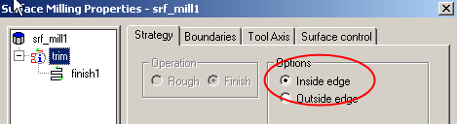
As we want the tool to cut “like an X-rotary tool”, we must also visit the Tool Axis tab, and choose the tool axis strategy of Lead/Lean with lead and lean angles of 0 (the default of toolaxis vertical will cut the feature with a “Z-tool”).
Run centerline simulation slowly. Notice that the tool is “inside out”, that is, by default, it cuts the wrong side of the surfaces.
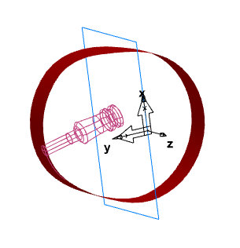
This is caused by the fact that in 5-axis simultaneous, Featurecam has no way of knowing which “side” of a surface to cut. I.e., that particular tool axis may be desirable in some case, but it is clearly not desirable in this case. To fix the toolpaths in this case, recall that Featurecam’s 5-axis will cut the “outside” of the surfaces. Solids generally have surface normals that point “outward”, whereas a random group of surfaces, such as an imported IGES file, may have randomly pointing normals. In this case, we got “unlucky” when we imported the IGES file, and our surface normals point “inwards”. To modify, visit the Surface Control tab of the trim operation, and toggle the surface side of both surfaces, verifying that the surface normal points outwards, or towards the side you wish to cut.
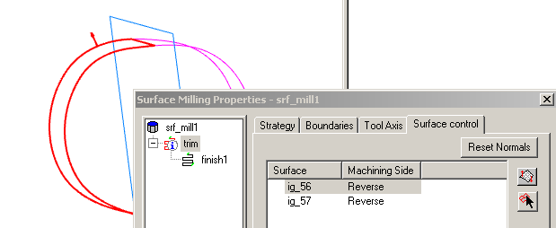
As an exercise for the reader, complete the trim operation and observe the toolpaths and tool positions carefully in centerline simulation. Do they cut the “walls” exactly? (Hint: Use the wall surfaces as check surfaces and see what happens to the trim toolpaths). Now construct a swarf toolpath of the wall surfaces. Use the same tool as the trim operation and compare the swarf toolpath to the trim toolpath. (They are not the same. Our conclusion to this exercise is that the wall surfaces in the IGES file are not modeled very accurately. FeatureCAM can cut the floor (with trim) or the walls (with swarf) accurately, but not both as modeled. To verify this, take a few angular measurements between the wall and the floor. There are places where this angle (which should be 90 degrees everywhere) approaches 88 degrees.

